TABLE OF CONTENTS

1 INTRODUCTION 2

2 HISTORY OF BUSINESS AND THE USE OF IS IN BUSINESS 3

3 TYPES OF BUSINESS 5

3.1 BRICKS & MORTAR 5

3.2 POINT & CLICKS COMMERCE 6

4 BRICKS & MORTAR AND POINT & CLICKS SIMILARITIES 7

5 BRICKS & MORTAR AND POINT & CLICKS DIFFERENCES 8

6 BRICKS & MORTAR AND POINT & CLICKS TENSIONS 9

6 CONCLUSION 10

REFERENCES 11

# 1 INTRODUCTION

Live in a digital/ globalized world affects everybody’s life in many different ways. Technology is needed nowadays for even simple tasks like calling, starting your car and buying food at the supermarket includes. But technology not only affected people’s life, it also affected organizations in ways that changed completely how they deal with consumers and other business. The use of internet is the most necessary item to live in such digitalized world.

Globalization has being interconnecting people and business since 1980s, when it emerged. To be global in a company’s perspective means that anybody can reach its products from anywhere and anytime. But on the other hand its advent also brought a new way of doing business and a new way of compete with other businesses, on the next topic this history will be explained, but for now it is important to understand a few concepts.

Previously – today is also included, the only market we knew was the physical shops, where customers can buy their product. The consumer has access to tangible goods. According to Laroche et al. (2005) when personally shopping, customers have the opportunity to inspect and to test the merchandise.

Furthermore with the advent of the internet, new forms of goods, services and delivery channels have raised bringing the E-Business, which is a different way of doing business. Nowadays, a firm does not exactly need to have a physical presence on the market; it can deliver its products online. Janita and Chong (2013) define E-Business as the process of exchanging, buying and selling through computer networks involving internet. E-Business is considered to be an innovation that thoroughly changed the traditional way of doing business (Bordonaba-Juste, Lucia Palacios and Polo Redondo, 2012).

These two ways of doing business are simultaneously in use nowadays, but each one of them has its features, its issues and it is very important to take into consideration how they affect modern businesses their differences and their similarities as well.

# 2 HISTORY OF BUSINESS AND THE USE OF IS IN BUSINESS

The internet has changed the way people, business and Information Systems (IS) operate. Focussing on organizations, which are using Internet technologies to enable their business processes and being innovative by creating e-business applications.

Based on Marakas and O’Brien’s (2013) book, we can see how business used to work and how it has developed since 1950s (Figure 1).

Firstly, business and IS within companies until the 1960s, were simple; focussed only on transaction processing, record keeping, accounting and electronic data processing applications.

In the next decade (1960s to 1970s), management information systems was born and provided managerial end users that gave managers the information they needed for their decision-making purposes.

Figure 1: Roles of Information Systems in Business and Management.

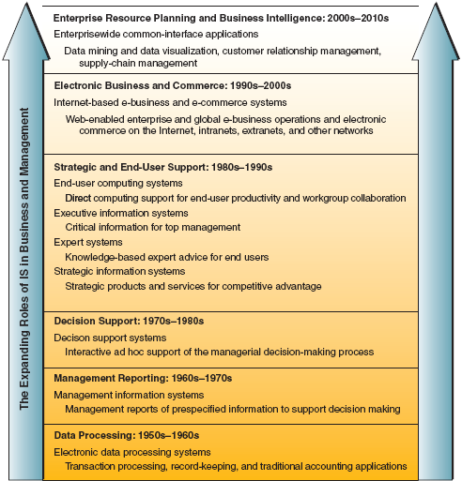

Source: Marakas & O’Brien (2013).

By the 1970s, the so far information products were not enough for management decision-making. That is when decision support systems was born, which provided managers with impromptu and interactive support for their decision-making processes. This support would be tailored as the managers confronted specific types of problems in the real world.

From 1980s, there were significant changes on information systems, like the development of microcomputer processing power, application software packages and telecommunications networks, which gave birth to the end-user computing. The concept of executive information systems developed, providing top executives and easy way to get the information they wanted, whenever they wanted and however they wanted. There were also a breakthrough in the development and application of Artificial Intelligence to business information systems. These applications replaced the need for human intervention and gave knowledge workers more complex tasks – Expert Systems, which today, serve as consultants providing expert advice in limited subject areas. And last, the strategic information systems emerged, turning information technology into an integral component of business processes, products, and services to help a company gain a competitive advantage in the global marketplace.

In the 1990s there was the emergence of enterprise resource planning systems. This strategic information system integrates all sides of a firm, like planning, manufacturing, sales, resource management, customer relations, inventory control, order tracking among others, which are all the business functions but virtually. Business Intelligence also emerged bringing all the applications and technologies in the organizations to gather and analyse data and information to be used to drive strategic business decisions. With its attributes organizations can gain insights – internal and external, that would affect the company’s business and competitiveness in the marketplace.

Finally, with the growth of the internet, intranets, extranet in the 1990s the capabilities of information systems in business dramatically changed at the beginning of the 21st century. Internet-based, web-enabled enterprises and global e-business and e-commerce systems became commonplace is the operations and management of today’s business.

# 3 TYPES OF BUSINESS

As mentioned before, the emerge of e-business brought a whole new level of doing business, it did not changed completely they way business operate, the difference is that now we have a higher level of systems and applications that take maximum advantage of business and strategic opportunities.

We have now two types of business, which can be connected or not as follow.

## 3.1 BRICKS & MORTAR

This type of business is basically the physical presence of a business or organization whether in a building or any other structure (Figure 2). This type of business offers a face-to-face customer experience, immediacy (try, buy, take home) and service (return, repair and exchange). It is considered as the “Business-as-usual” by (Kalakota & Robinson, 2000).

Figure 2: Bricks & Mortar Representation.

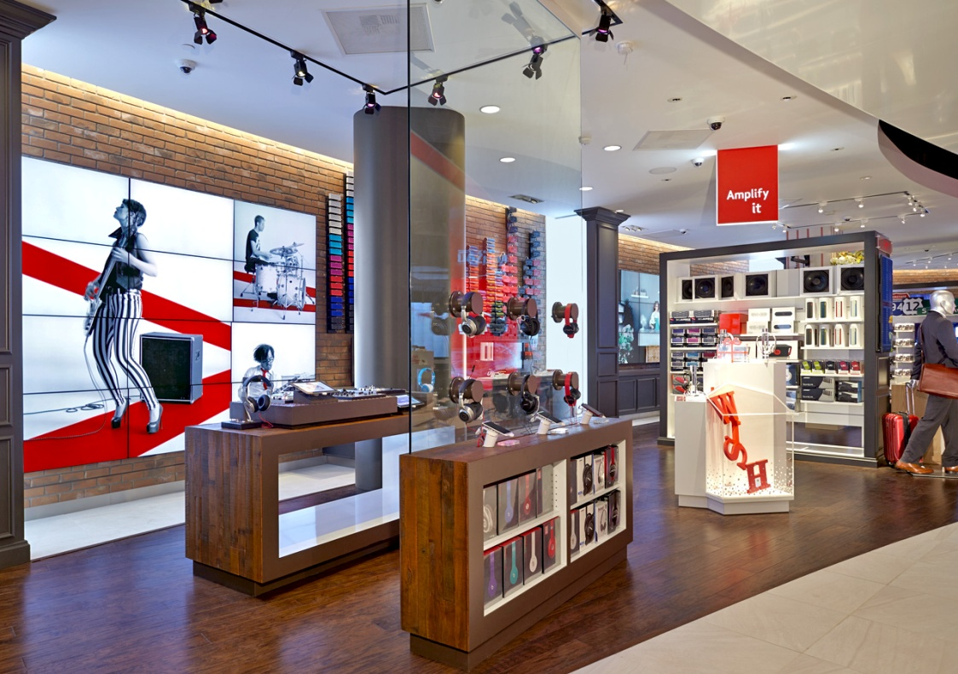

Source: Pinterest (2017).

## 3.2 POINT & CLICKS COMMERCE

This type of commerce is commonly called E-Business (Figure 3) which refers to the use of Information and Communication Technologies (ICT) by business with the purpose of enhances production, customer engagement and internal management. This term is usually misused as E-Commerce which “refers to the use of ICT to undertake transactions such as business to business (B2B) and business to consumer (B2C); in essence selling goods and services via the internet” (Daniel, Wilson & Myers, 2002. Cited in Mazzarol, 2015). Even though they are connected they are not the same.

Marakas and O’Brien (2013) define E-Business as “the use of IT to work and empower business processes, e-commerce, and enterprise collaboration within a company and with its customers, suppliers, and other business stakeholders”.

Figure 3: E-Business icon illustration.

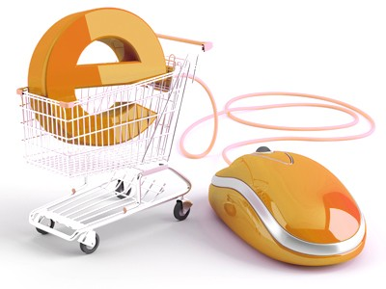

Source: Sourcepoint Industrial (2017).

The next topics will be explored by the similarities, differences and the issue of each one of the type of business.

# 4 BRICKS & MORTAR AND POINT & CLICKS SIMILARITIES

When talking about commerce, whether is on line or physical, both have the same goal, which according to the Cambridge Dictionary, is the activities involved in buying and selling thing. McQuerrey (2017) add that the goal of reaching the greatest number of potential customers.

Still according to McQuerrey (2017), both Bricks and online business need to know their target audience before start any activity towards reach them. For this purpose, they need to establish marketing presence; especially online marketing, which can include social media such as Facebook, LinkdIn and Twiter. To raise the incentive on products, both types of business use customer incentives as a marketing tool such as conducting crossover promotion between both on and off line products. Both types of company have the great need to attract and retain and turn customers into repeat buyers.

Store experience has an important impact on overall sales, whether on and offline (Doornbosch, 2017). For example, a customer can have a great experience in-store but still decide to buy it online and the same happens with online stores, if the customer has a good experience once by shopping online, it will make him curious to get to know the physical shop, which might have more options than online. Mark also emphasises loyalty and add to what McQuerrey (2017) said that loyal customer will always repeat shopping with such company even if it is not the lowest price on the market.

Online and offline business both still need information systems to support their activities. Taking Office Depot’s strategy as an example, we can see that the company, after integrating its physical presence with its web presence, has developed a sophisticated information system which contains complete product, vendor, customer, and order information as well as real time inventory data for each store and warehouses the company possess (Gulati & Garino, 2000).

# 5 BRICKS & MORTAR AND POINT & CLICKS DIFFERENCES

If we look at how these two businesses deliver their products, it is easier to see their differences. Starting with one (Bricks) is a physical shop and the other (Point) is an online store which might possess a warehouse but the customer usually does not have access to it.

If we take tangibility/ intangibility into consideration, Laroche et al (2001) cited in Laroch et al (2005) says that “intangibility has strong impact on consumer decision-making” which means that it is an important feature whether is easy or difficult for a customer when making a pre-purchase evaluation of the item.

When shopping in store, the consumer can reduce uncertainty by inspecting or testing the merchandise (Laroche et al., 2005). It confronts the idea of trusting the seller which might be very important when pursuing loyalty with repeat buyers. On the other hand, internet can easily provide customers with appropriate information and diminish the effort needed to get the information (Thakor, Borsuk, and Kalamas, 2004. Cited in Laroche et al., 2005).

Still according to Laroche et al (2005), the internet provides easy evaluation of products by screening the many options offered to find the most appropriate for consideration, it also offers unrestricted search across different brands and stores. And finally, internet has the ability to remember past selections. Meanwhile, Bricks and Mortar business gives the costumer the opportunity to get both in store information like brand name, packaging design, presentation and sales people’s help.

Physical business allow customers to socialize and entertain themselves while during their shopping while online shopping is impersonal and not exciting (Doornbosch, 2017).

Online businesses have the potential for global reach; as seen before, customers need to have information/ products anywhere and anytime; while in store shopping limit the access to products by having or not a store close to consumer’s house/ work and the customer needs to be available at the same time he needs the product to go and pursue it, which is often out of reach (McQuerrey, 2017).

# 6 BRICKS & MORTAR AND POINT & CLICKS TENSIONS

There are also points that limit, or bring issues for both Bricks & Mortar and Point & Click business.

Cox &Rich (1964) cited by Laroche et al.,(2005) said that when buying online the customer does not offer visual or tangible signs making the purchasing to be riskier to the customer than bricks & mortar shopping, also, there is also the issue with privacy and security concerns.

By pursuing online, buyers have to trust the quality of the goods or services and trust the seller to deliver their purchase and not to misuse their information like address and telephone numbers (Clarke, 1997. Cited in Laroche et al., 2005). The server administration is also involved when the buyer must trust the seller with administration security such as credit card information.

Both business need to reach consumers at a high level that makes them want to come back; this feeling is achieved according to Doornbosch (2017) by creating a remarkable experience. The biggest challenge of this purpose is create a comfortable and invite store that is enjoyable for customers to spend time in, which includes online shopping. Mark also said that 66.4% of shoppers uses Facebook or other social media to tell friends about deals or finds and from that, consumers are 71% more likely to make a purchase based on social media referrals which makes crucial for business (online and physical) to invest in shopping experience.

Traditional Bricks & Mortar business are forced by its nature to have a physical presence on the market, which means they have to spend a huge amount of capital on personnel, rent (or a buy a place), equipment, etc, especially if they are trying to reach a global marketing.

Online business does not have to spend great capital on its business but on the other hand, it has to invest better on offering an experience with quality for shoppers due to keep them for future purchases.

# 6 CONCLUSION

The world for business was already competitive even before the advent of internet and with globalization and digitalization, the competitiveness became stronger.

Business need to work harder to stay on the market. After said that is important to mention that most of Bricks & Mortar business became Cricks & Click which means they have both physical and online presence.

Both ways of doing business are important nowadays, and it is imperative for companies to merge from only traditional business to the online business, which does not mean that it should withdrawn the physical activity on the market. Buyers still enjoy experiencing shopping in store and having physical contact with other people.

Either Bricks or Point have issues and benefits but combined they can stay for long in the market. Some features need to be taken care specially like safety and security for both consumers and business while doing Business to Business (B2B) and Business to Consumers (B2C).

# REFERENCES

Bordonaba‐Juste, V., Lucia‐Palacios, L. and Polo‐Redondo, Y. (2012). Antecedents and consequences of e‐business adoption for European retailers. *Internet Research*, 22(**5**), pp.532-550.

Doornbosch, M. (2017). *The Relationship Between Online and Brick And Mortar | MarketSource*. [online] MarketSource. Available at: http://www.marketsource.com/the-relationship-between-online-and-brick-and-mortar/ [Accessed 21 Nov. 2017].

Gulati, R., & Garino, J. (2000). Get the right mix of bricks & clicks. *Harvard Business Review,* *78*(**3**), 107-14, 214.

Janita, I. and Chong, W. (2013). Barriers of B2B e-Business Adoption in Indonesian SMEs: A Literature Analysis. *Procedia Computer Science*, 17, pp.571-578.

Kalakota, R. and Robinson, M. (2000). *E-business*. Reading [etc.]: Addison-Wesley.

Laroche, M., Yang, Z., McDougall, G. and Bergeron, J. (2005). Internet versus bricks-and-mortar retailers: An investigation into intangibility and its consequences. *Journal of Retailing*, 81(**4**), pp.251-267.

Marakas, G.M. and O'Brien, J.A., (2013). *Introduction to information systems*. 16th edn. McGraw-Hill, Inc., New York.

Mazzarol, T. (2015). SMEs engagement with e-commerce, e-business and e-marketing. *Small Enterprise Research*, 22(1), pp.79-90.

McQuerrey, L. (2017). *Similarities Between Brick-and-Mortar Business and E-Business Marketing*. [online] Smallbusiness.chron.com. Available at: http://smallbusiness.chron.com/similarities-between-brickandmortar-business-ebusiness-marketing-21174.html [Accessed 20 Nov. 2017].

Pinterest. (2017). *Interactive New Media*. [online] Available at: https://www.pinterest.ie/pin/162270392797567883/ [Accessed 23 Nov. 2017].

Sourcepoint Industrial. (2017). *E-Procurement Capabilities*. [online] Available at: http://sourcepointindustrial.com/e-procurement-capabilities [Accessed 26 Nov. 2017].